**Users Collection**

**FireStore:**

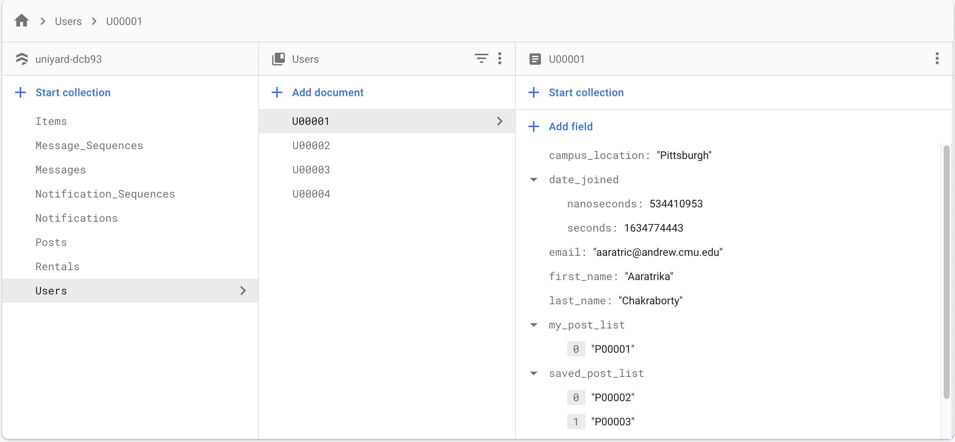

**Struct:**

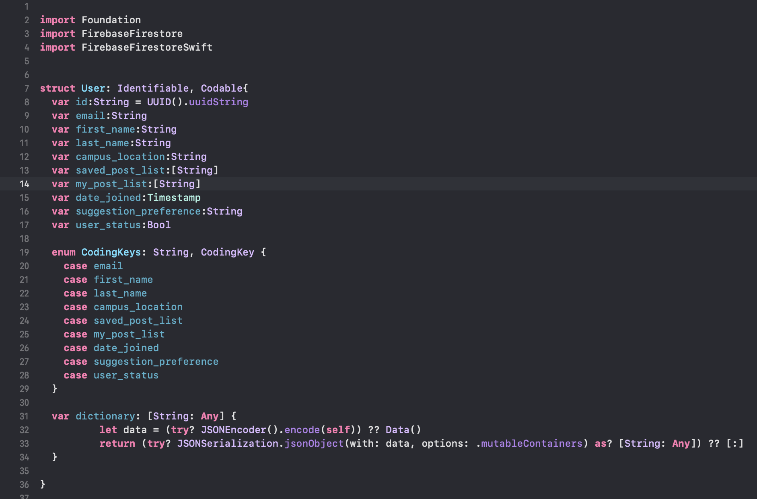

**Output in console:**

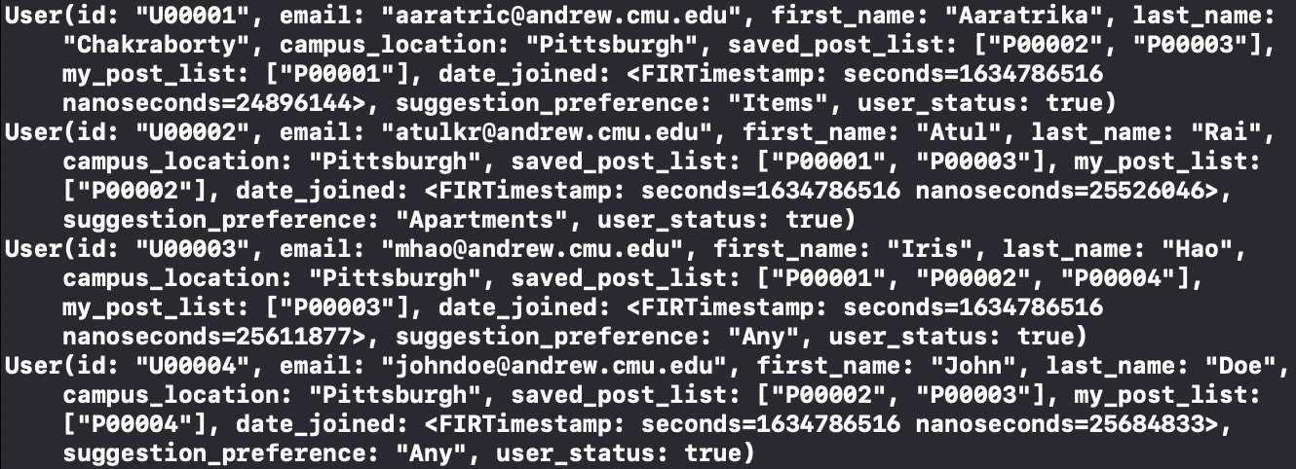

**Posts Collection**

**FireStore:**

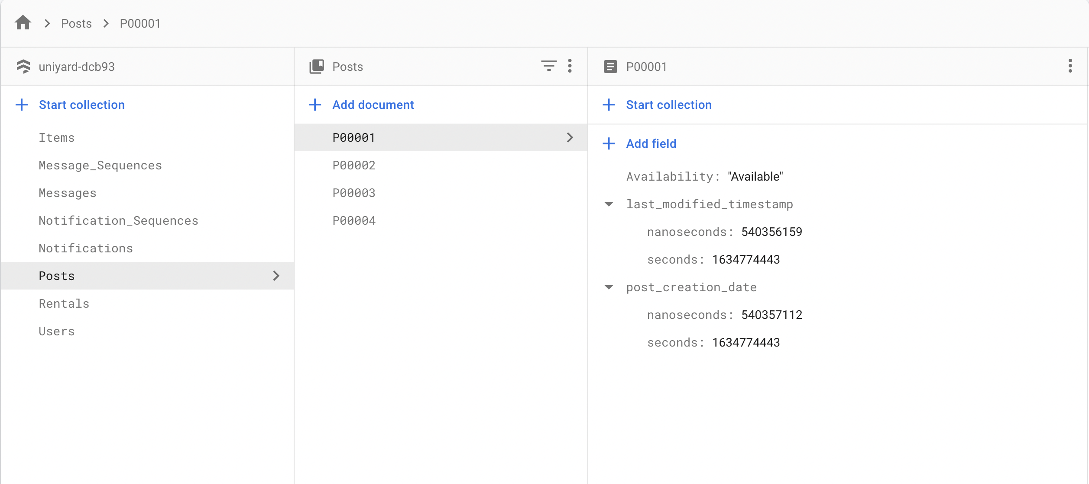

**Struct:**

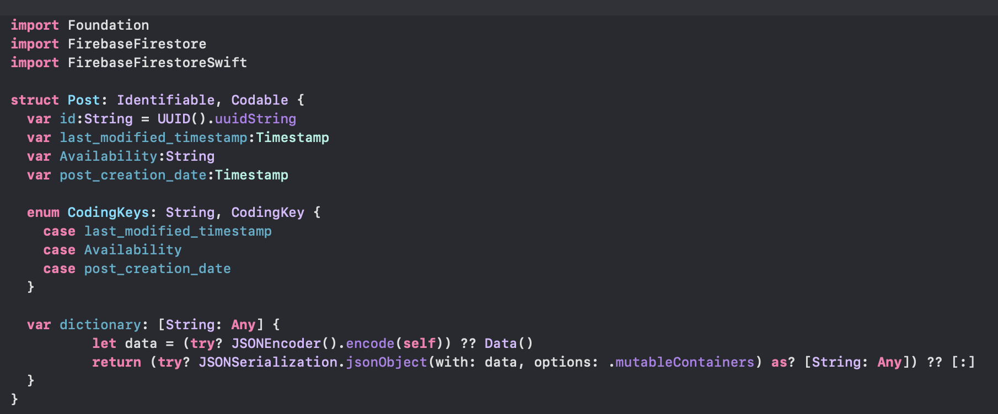

**Output in console:**

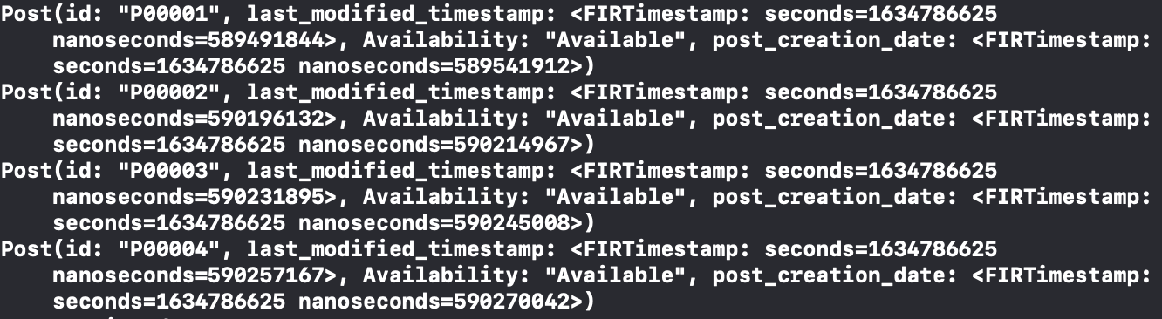

**Items Collection**

**Firestore:**

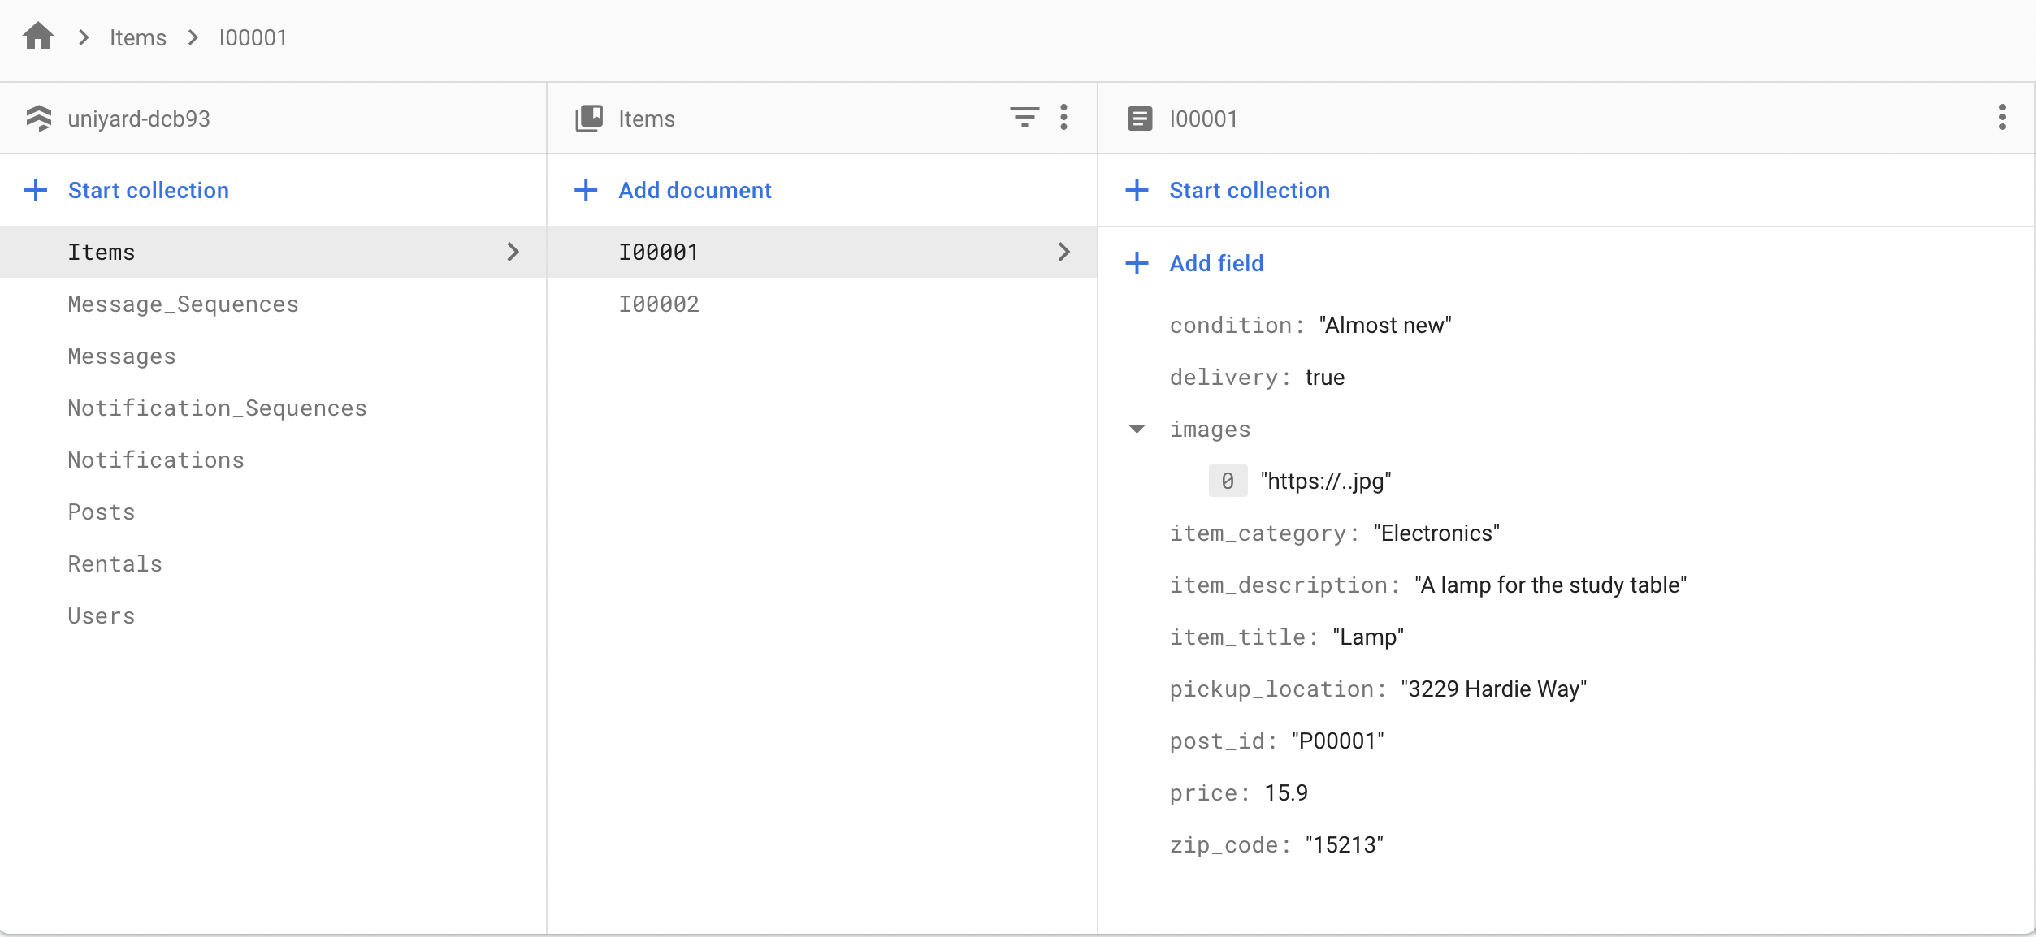

**Struct:**

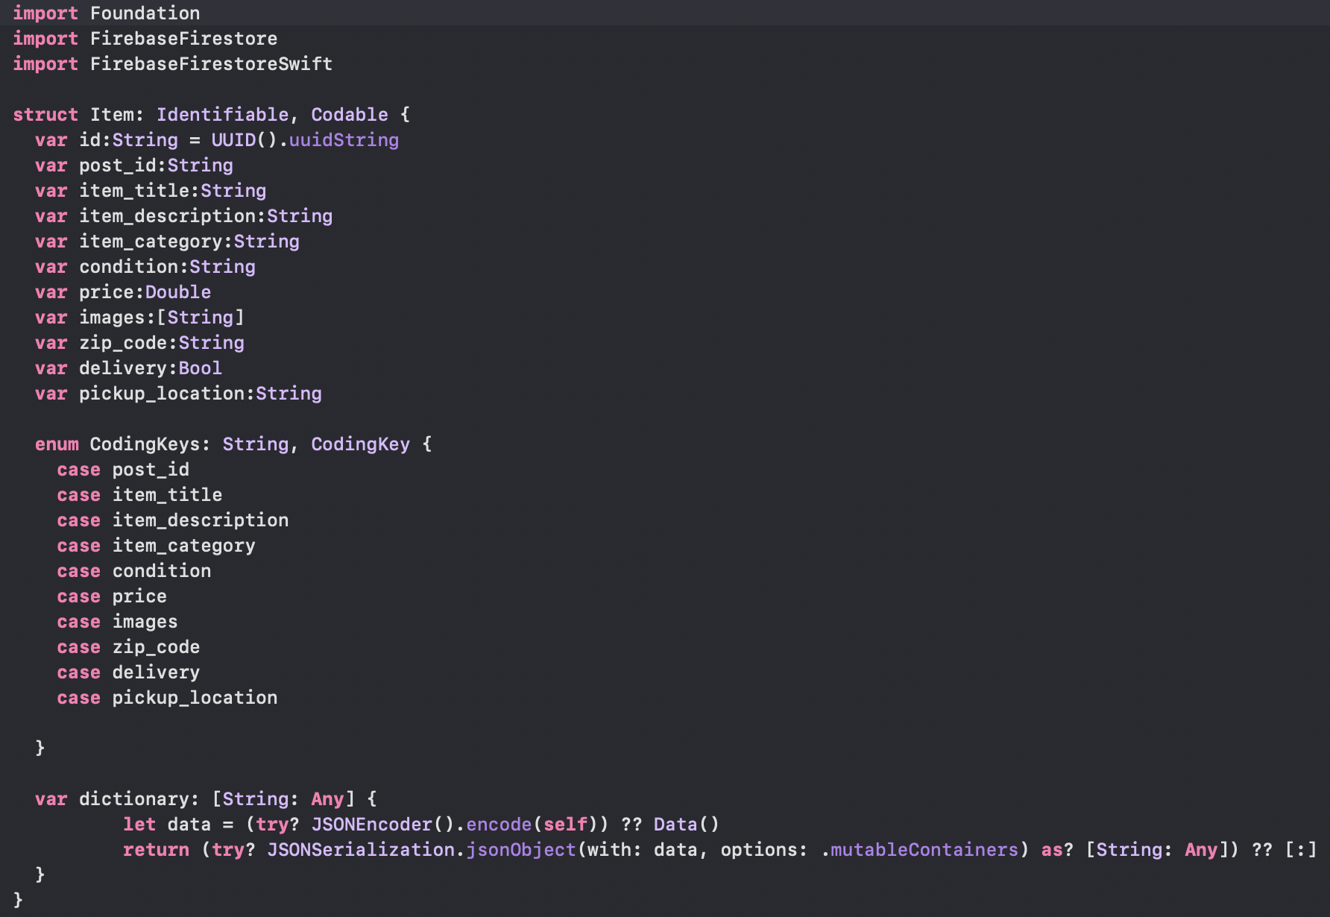

**Output in console:**

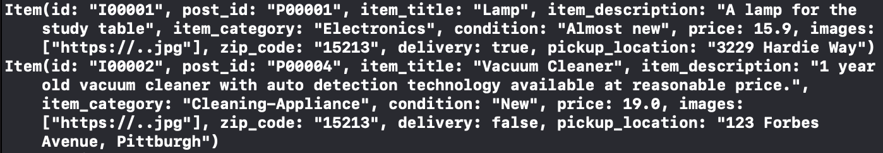

**Rentals Collection**

**Firestore:**

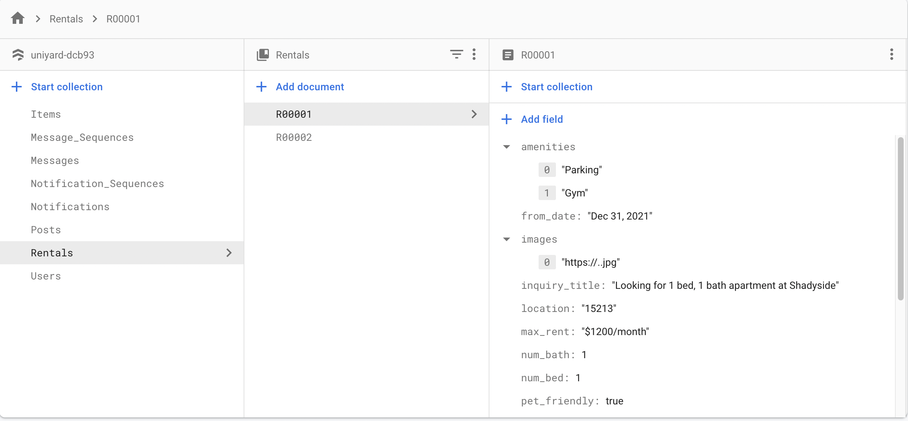

**Struct:**

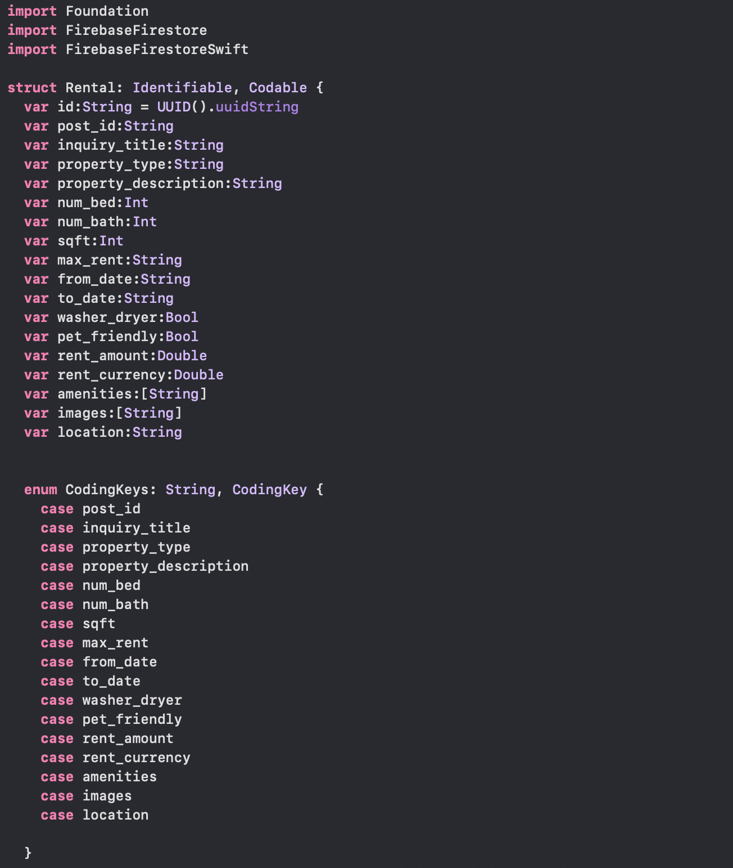

**Output in console:**

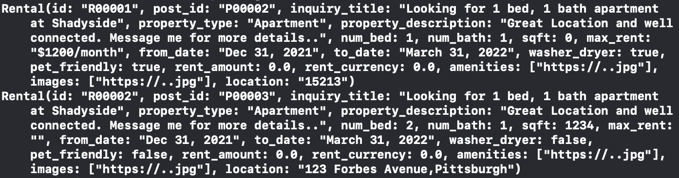

**Messages Collection**

**FireStore:**

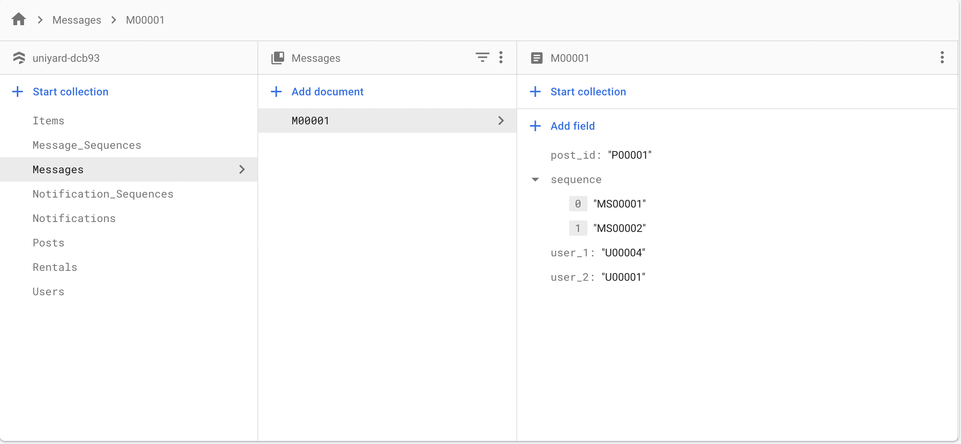

**Struct:**

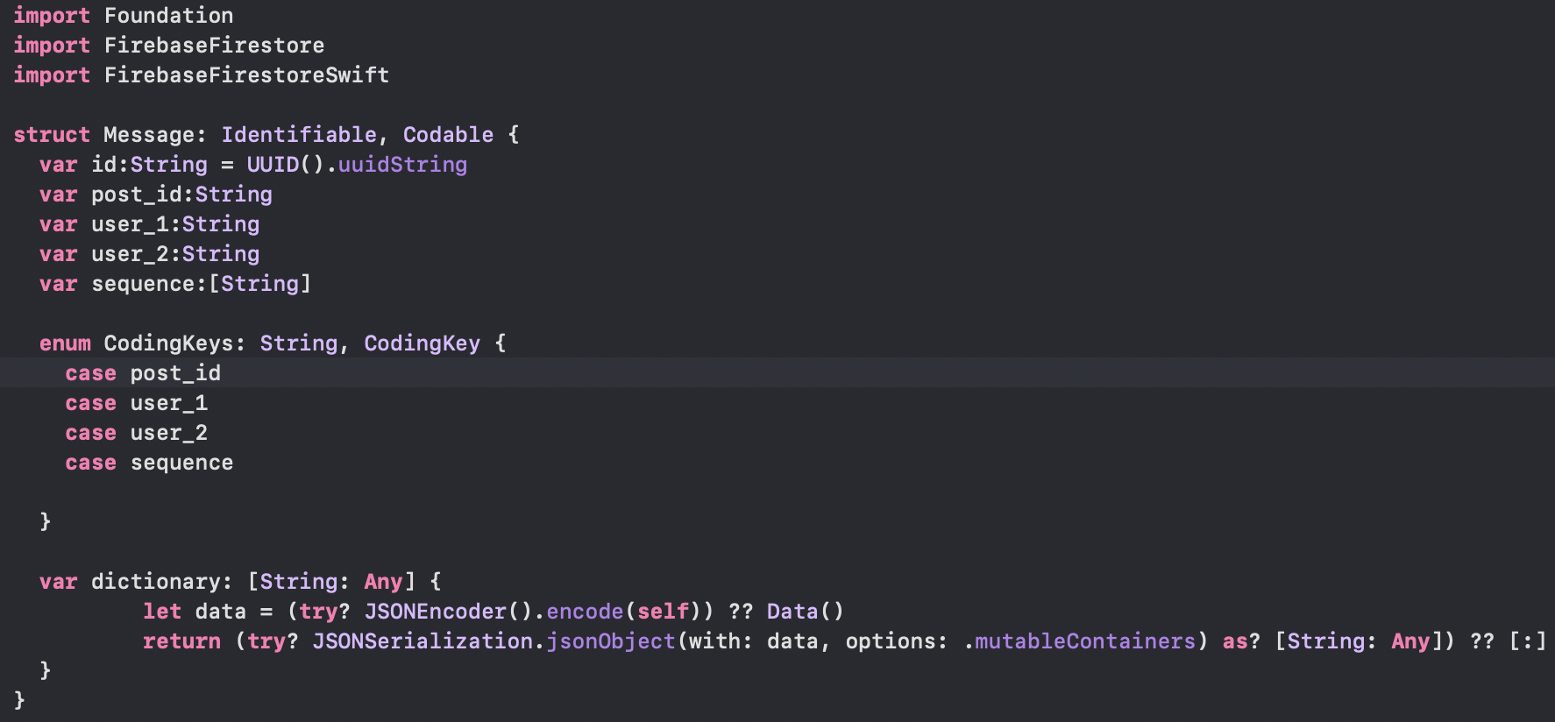

**Output in console:**



**Notifications Collection**

**FireStore:**

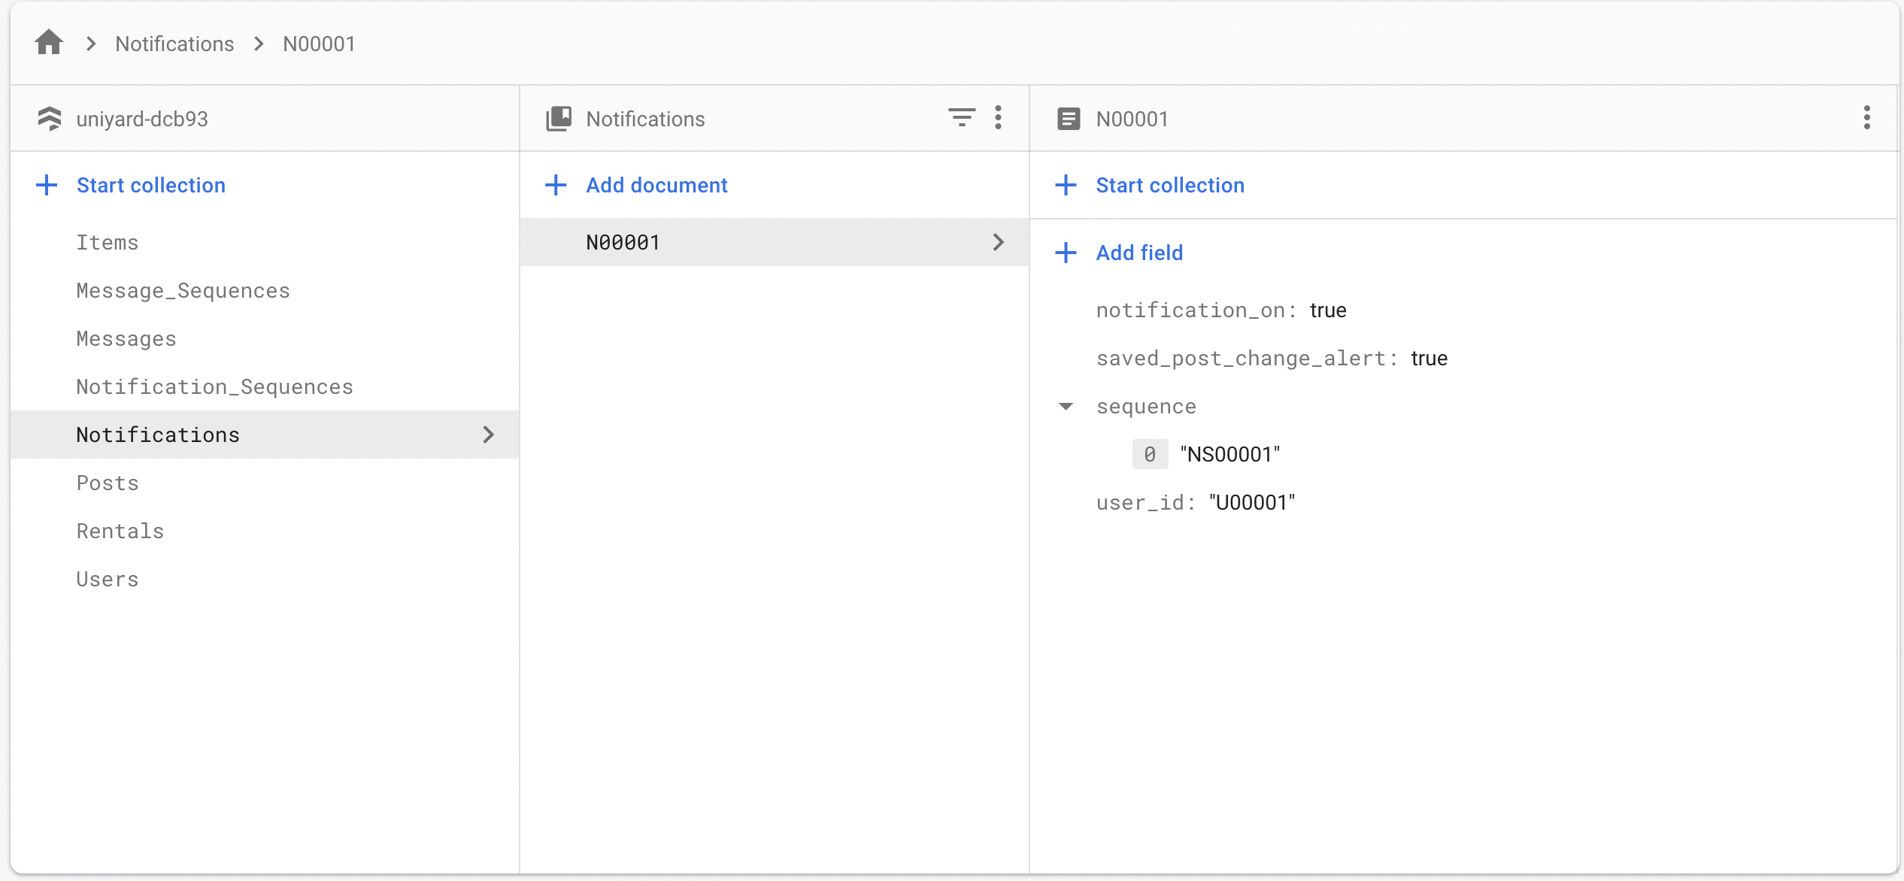

**Struct:**

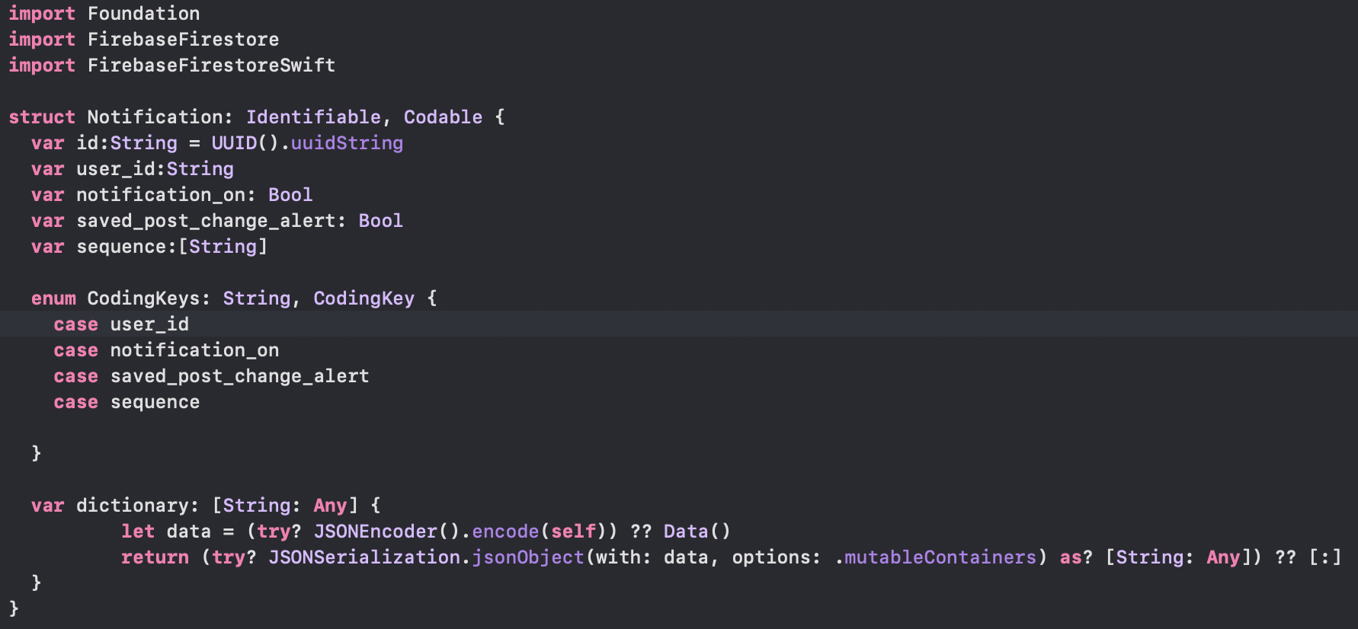

**Output in console:**



**Message_Sequences Collection**

**FireStore:**

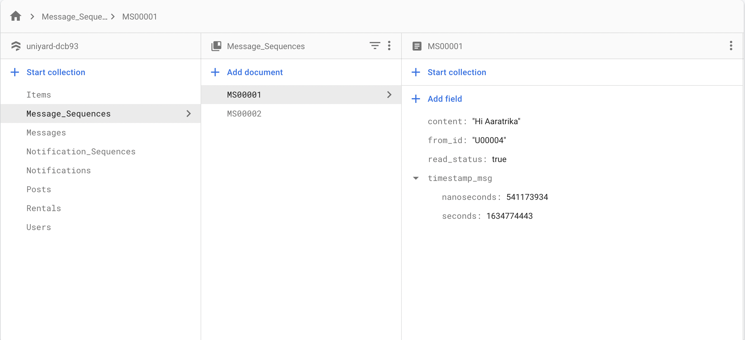

**Struct:**

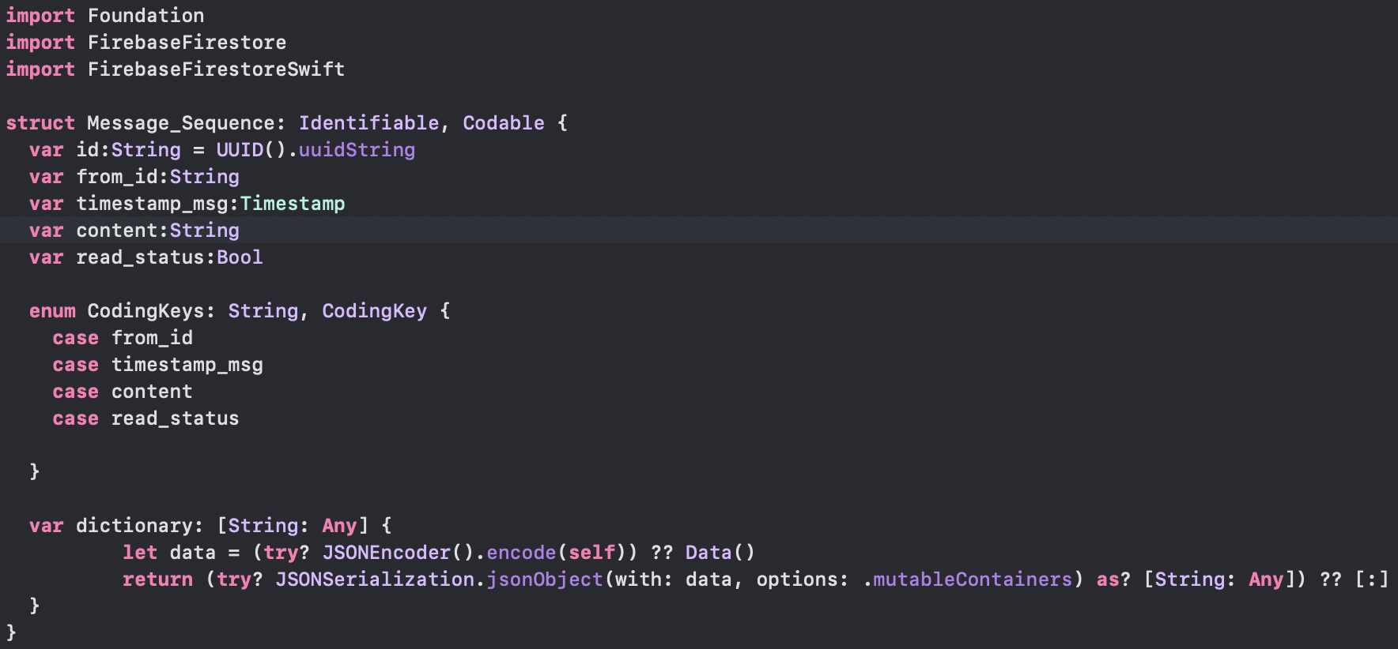

**Output in console:**

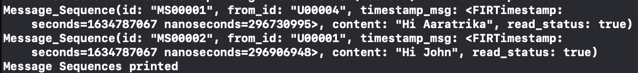

**Notification_Sequences Collection**

**FireStore:**

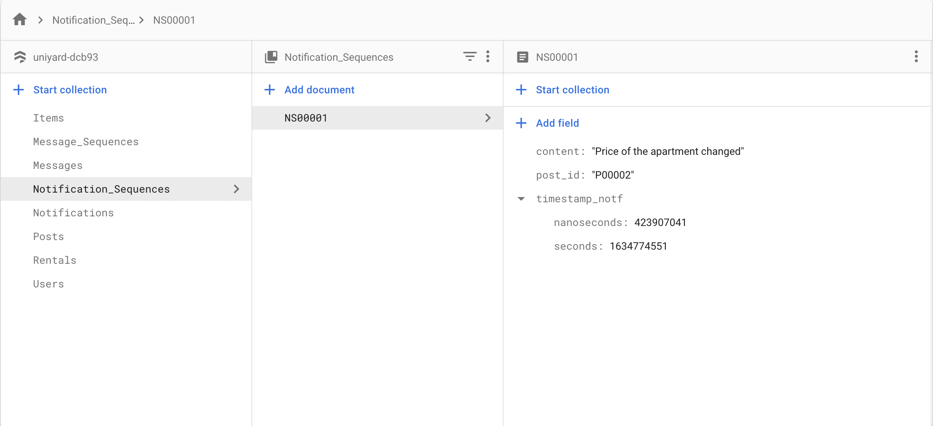

**Struct:**

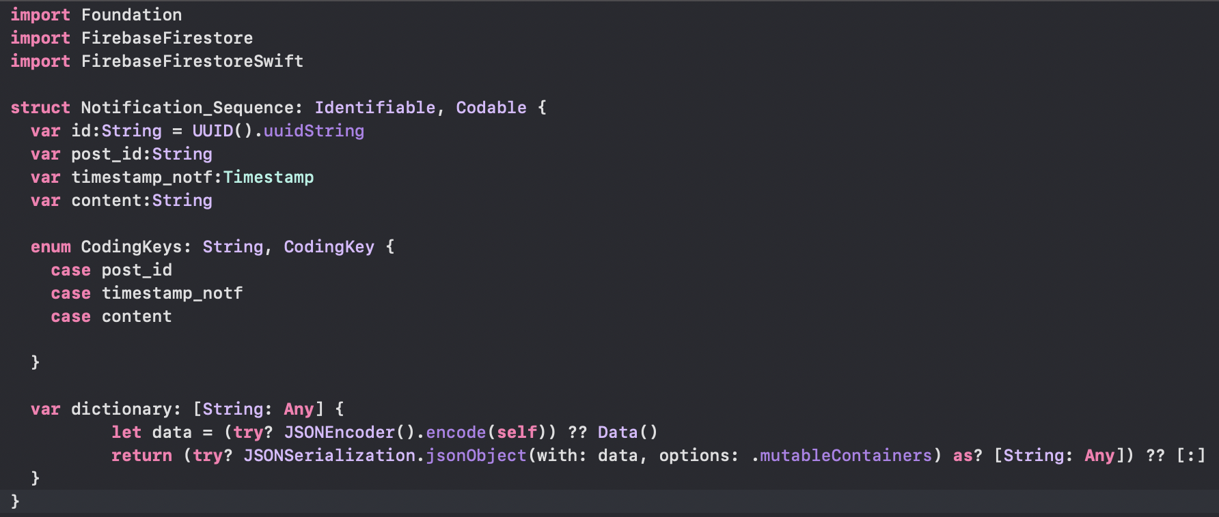

**Output in console:**

